HW 5.2

TU23FL-CAD

Dr. Laura Riggio

Jakob Werle

2023-10-23

Contents

Introduction 2

Procedure 2

Results 4

Discussion 6

# Introduction

A solid element simulation will be created for a simplified hacksaw frame to replicate the loads applied by a saw blade. The scenario will be simulated with given fixtures and applied loads. The simulation results for stress will then be compared to theoretical calculations.

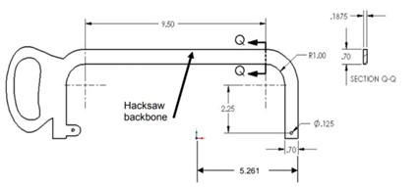

Figure Hacksaw Drawing

The above drawing depicts the model dimensions and constraints.

# Procedure

A hacksaw SOLIDWORKS part model from the CAD textbook was used to create a solid element model. First, a static simulation was created. Next, the left side hole was fixed. Using an offset plane and split line, a small region was made on the inside face of the right hole. A 50lb force directed to the left was applied to simulate the tensile force created by a saw blade while cutting with the saw. A standard, high quality mesh was created and checked over for irregularities.

Hacks„ 
FO rce/Torque 
Type split 
Torque 
O Selected direction 
O Per item 
Total 
Units 
English ups 
Force 
Y:' 50 
Reverse direction 
Nonuniform Distribution 
Symbol Settings 
•Dimetric 
Along Edge (Ibo. 50 

Figure Force Applied to Small Region in Right Hole

Figure 2 shows the small region created using a split line. The applied force is applied only to the region’s face.

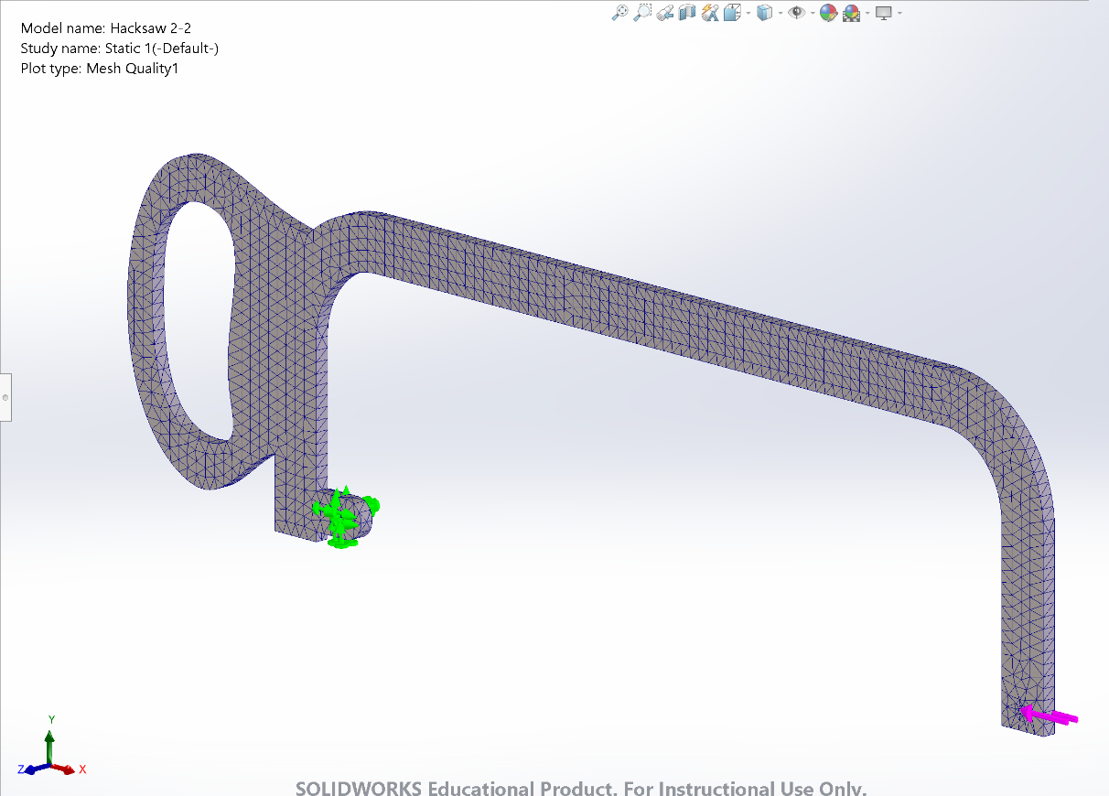

Figure Solid Element Model

Figure 3 shows the SOLIDWORKS simulation constraints and mesh results.

The simulation was ran and then contour plots were setup to display stress. The stress was probed along the nodes and element midpoints aligned vertically with the centroid of the saw backbone’s constant radius bend, which is denoted as Section Q-Q in the problem.

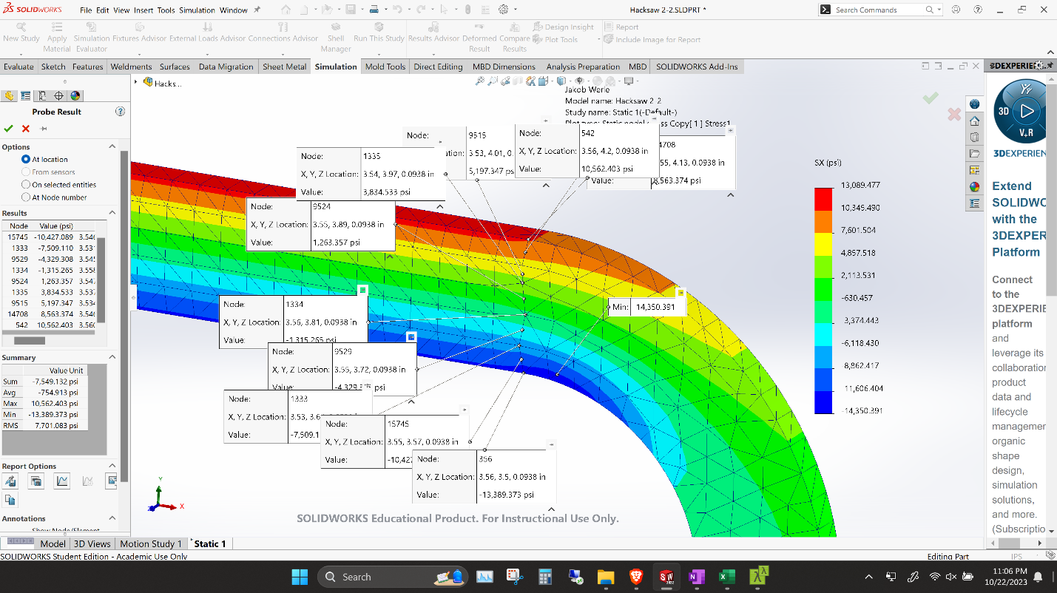

Figure Probing Section A-A

Figure 4 displays the process of probing points at Section Q-Q and recording their values.

A factor of safety plot was then created to show where FoS fell below 4.

# Results

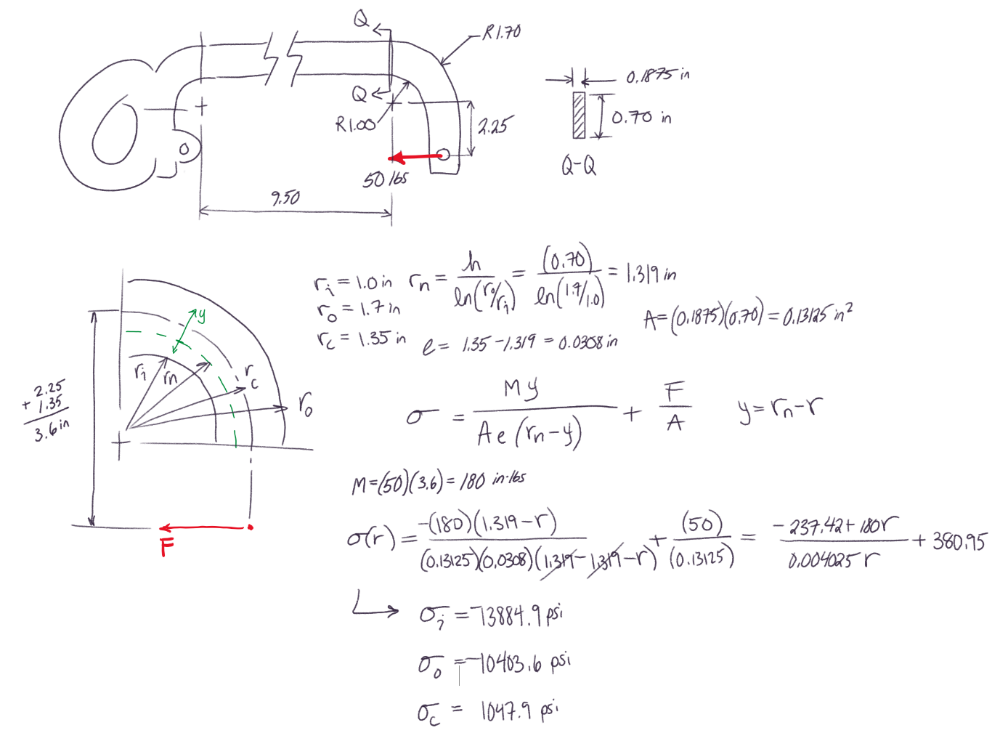

Figure Theoretical Hand Calculations

Figure 5 goes through the hand calculations to solve for the stress at the inner, centroid, and outer stresses at Section Q-Q.

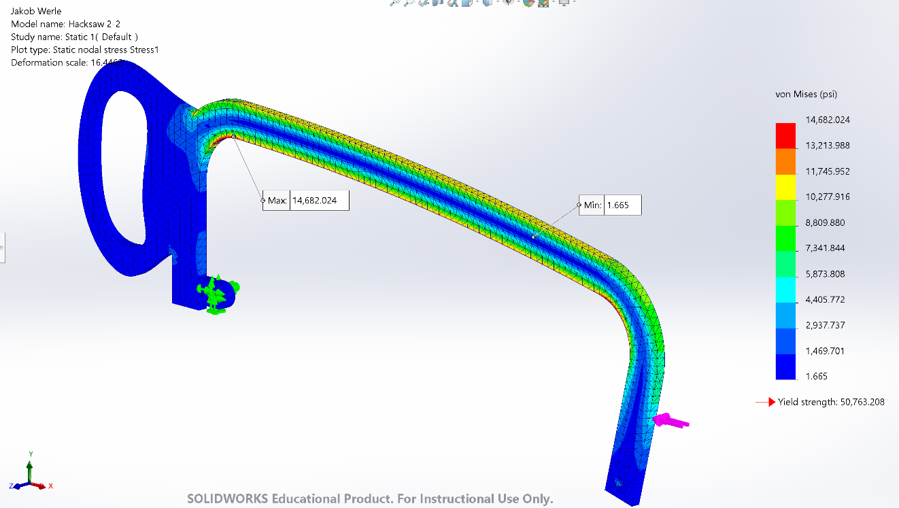

Figure von Mises Stress Contour Plot

Figure 6 displays the contour plot for von Mises stress. Maximum and minimum stress locations are labeled according.

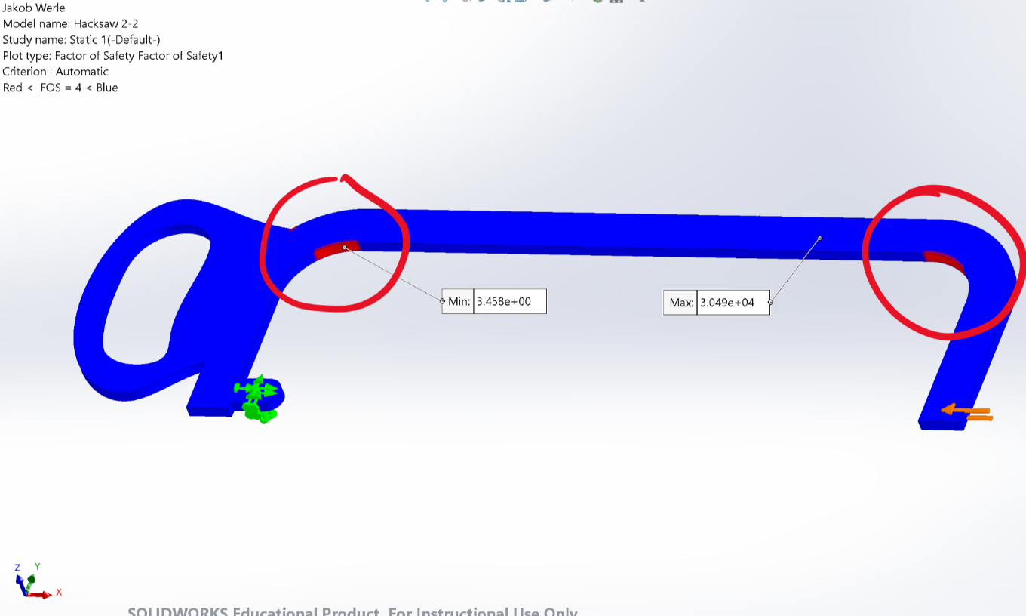

Figure Contour Plot of FoS < 4

Figure 7 shows the contour plot for the factor of safety falling below 4. Minimum and maximum values of factor of safety are also labeled.

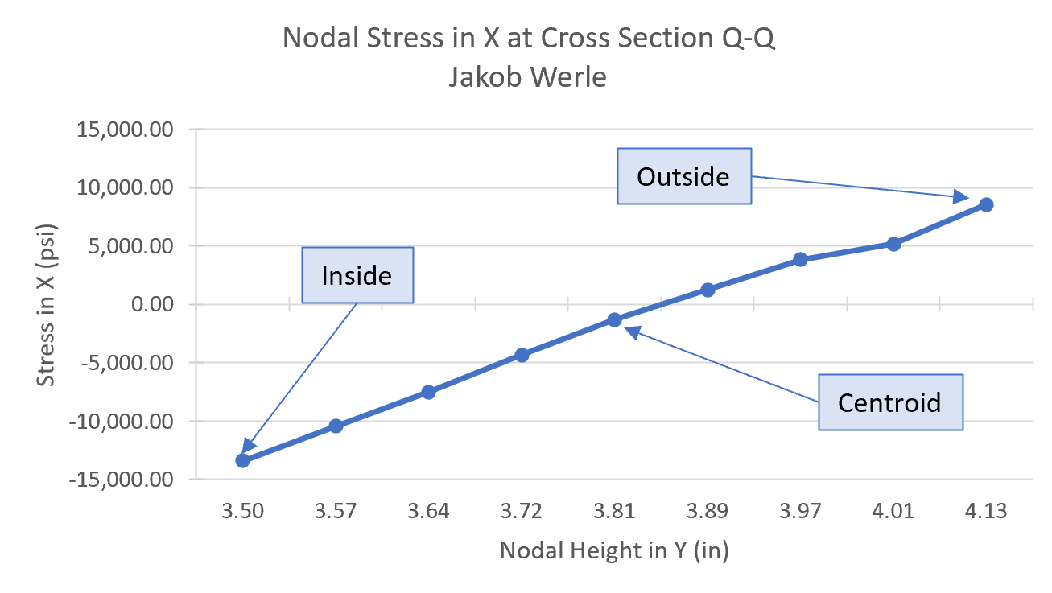

Figure Stress vs Y Position Graph

Figure 8 is a graph that plots the stress in the X direction against the position of each node in the Y direction at Section Q-Q. Normal stress in noted at the inside, centroid, and outside of the saw frame’s cross section.

Figure Refined Mesh Model

Figure 9 shows the refined mesh model generated using a mesh control. The inside and outside nodal stresses are displayed.

Figure Refined Mesh Stress Graph

Figure 10 displays the same information as Figure 8 but using a mesh control to refine the mesh. The original, standard mesh model values (orange) were plotted against the refined values (blue).

Table Results Comparison

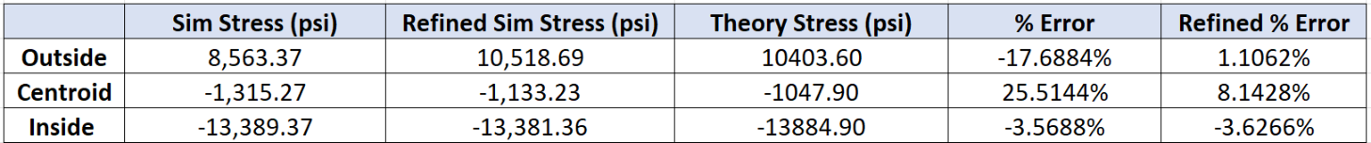

Table 1 displays the percent error between simulation and hand calculated results for stress in the inside, center, and outside of the saw frame. The same percent error comparison is shown for the refined mesh model.

# Discussion

The calculated inside, centroid, and outside stress can be seen in Figure 5. Simulated results for the same stresses can be found in Figure 8, plotted against their vertical position. As seen in Table 1, the margin of error between hand calculations and original simulation results varied up to 25%. While the inside stress error was only ~3.6%, the large error for the other locations suggests a mistake in hand calculations or an inaccuracy in the solid element model.

To determine the root of the error, another simulation was ran with a refined mesh. Once the simulation was re-ran and re-probed, values were plotted against the original results, as seen in Figure 10. In can be seen that using a more refined mesh allow many more nodes to be analyzed. The percent error for the inside, centroid, and outside stress were reduced to no more than ~8%, as shown in Table 1. This trend supports the claim that the solid element model has room for improvement.

Since there is still a reasonably large error in simulation values, it questions the validity of the solid model analysis. However, since the factor of safety was above 3, it could be determined that this hacksaw design is functionally sound. Other considerations to consider are the simplicity of the hand calculations, simplicity of the SOLIDWORKS model, and the way in which the force was applied to the saw frame. In reality, a hacksaw would not likely be made of a thin sheet metal. A more accurate base model could alleviate this discrepancy, although more challenging to analyze. Regardless, further analysis would probably be of good practice for a product like this to go to market.